CONVERSION SYSTEM OF EARTHQUAKE DATA FROM MICROSOFT EXCEL TO DATABASE AT INDONESIAN AGENCY FOR METEOROLOGICAL, CLIMATOLOGICAL AND GEOPHYSICS DENPASAR

Gusti Made Arya Sasmita¹ , I Gusti Putu Krisna Pradiptha²

Information Technology, Faculty of Engineering, Udayana University,
Bukit Jimbaran
Denpasar, Bali, Indonesia
aryasasmita@it.unud.ac.id, pradipthakrisna@gmail.com

Abstract

Earthquakes are earth shaking events due to the sudden release of energy due to tectonic plate movements in the rigid crust or other causes. The energy released in the form of seismic waves that radiate in all directions to the surface of the earth. An earthquake has parameters that can be analyzed by humans using a special tool. Data parameters are stored and used to analyze and study the movement of tectonic tectonics, volcanic activity and the earthquake itself. In Indonesia the earthquake data recording is done by the Center for Meteorology, Climatology and Geophysics which storage of earthquake parameter data using Microsoft Excel. The development of science in the field of information technology encourages the creation of a system that can record web-based earthquake data that can convert data from Microsoft Excel table into database tables to facilitate data processing in the future by BBMKG (Balai Besar Meteorologi, Klimatologi, dan Geofisika) Region III Denpasar
Keywords: Earthquake, System, Earthquake Data.
I. Introduction

Earthquakes are earth shaking events due to the sudden release of energy due to the movement of tectonic plates on the crust of the earth are rigid. The energy released in the form of seismic waves that radiate in all directions to the surface of the earth. The consequences of an earthquake can cause disasters that harm the environment and society. An earthquake has characteristics, these characteristics are usually called earthquake parameters. The bias earthquake parameter consists of the date of the incident, the time, the strength of the earthquake, the scene and the depth of the earthquake. These earthquake parameters are recorded and stored for further analysis and assessment of earthquake information data. The body responsible to record all tectonic activities (earthquakes) in Indonesia is the Meteorology, Climatology and Geophysics Agency or abbreviated as BMKG.Storage of earthquake parameter data record in BBMKG Region III Denpasar still using Microsoft Excel. Associated BBMKG Region III Denpasar is currently doing system renewal, hence making design of earthquake parameter data conversion system to be implemented further. Based on the problems that have been described, currently the Center for Meteorology, Climatology and Geophysics Region III Denpasar needs a system that can convert data from Ms.Excel into the database and can directly store earthquake data into the database, then as students of practical work I want to implement an Earthquake Parameter Listing system that aims to save energy and time in work.
II. Research Methodology

The research methodology used in the development of Implementation Of Data Parameter Conversion System Of EarthQuake From Microsoft Excel To Database In BBMKG III Denpasar is Design Science Research Methodology (DSRM). The methodology was focused on problem-solving and system development [1]. DSRM has six stages used as a reference in conducting research such as below:
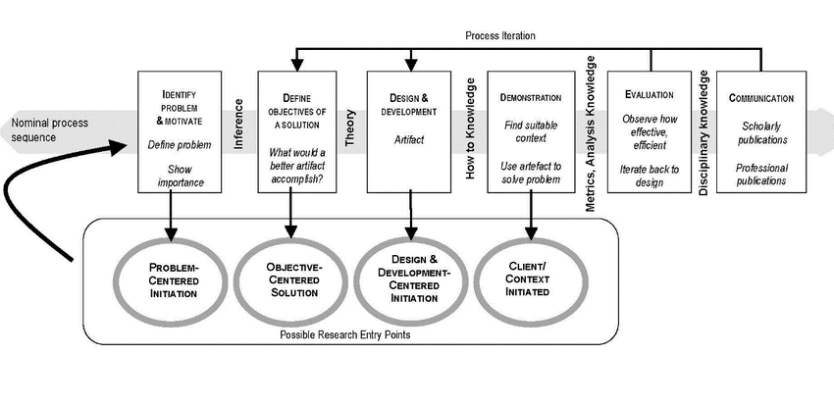
Fig. 1 Design Science Research Methodology
The research methodology used in the development of Implementation Of Data Parameter Conversion System Of EarthQuake From Microsoft Excel To Database In BBMKG III Denpasar is shown in Figure 1. DSRM consists of problem identification and motivation, identifying object and solution of the problem, design and development, demonstration, evaluation and communication focused on the purpose of solving the problem.

2.1 Application’s Overview
Designing Implementation Of Data Parameter Conversion System Of EarthQuake From Microsoft Excel To Database In BBMKG III Denpasar using Codeigniter framework. The Earthquake Parameter Data Conversion Data System from Microsoft Excel to Database will provide special services for admins, admins can manipulate data (insert, update, delete) into the system. Here is an overview of the Earthquake Data Parameter Listing System. The application works as below:

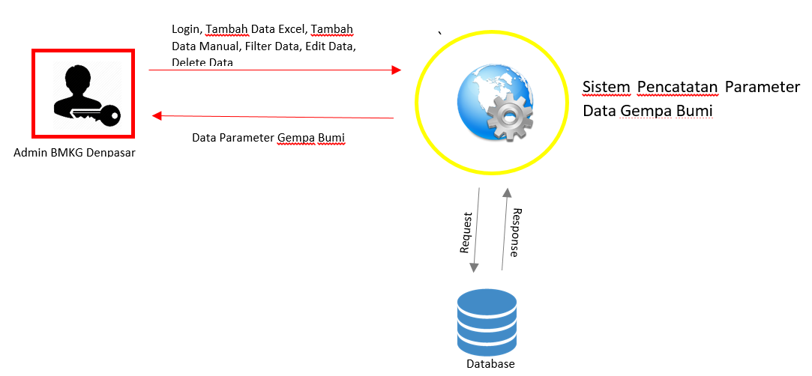 Fig. 2 Application’s Overview
Fig. 2 is an overview of Implementation Of Data Parameter Conversion System Of EarthQuake From Microsoft Excel To Database In BBMKG III Denpasar. The Earthquake Parameter Data Conversion Data System from Microsoft Excel to Database only has one entity ie admin. Admin here has the right to manipulate data (insert data, update data and delete data).
2.2 System Architecture Design
System architecture design is an overview of the entire process on the application and features that exist within it, which aimed to facilitate in understanding the process on the application.

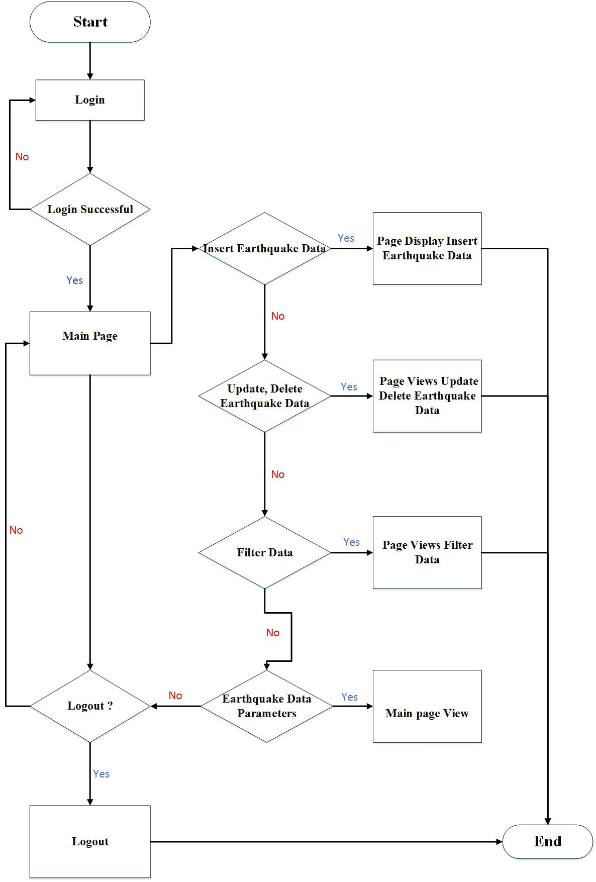

Fig. 3 The System Architecture Design
Fig. 3 is the system architecture design of Implementation Of Data Parameter Conversion System Of EarthQuake From Microsoft Excel To Database In BBMKG III Denpasar. The First, user login by entering username and password that have been set before. Then if the username and password entered does not match then the user will repeat the login until the username and password accordingly. When the login has been successful it will switch to the admin dashboard page or main page, on the dashboard page there are 5 menus that can be used to manipulate data in the database that is filter data menu, reset, add data, edit and delete. If the admin does not do something then the process is completed or the admin will do the Logout process.

III. Literature Review
An earthquake is a vibration or shock that occurs on the earth's surface due to the sudden release of energy from within that creates a seismic wave. Earthquakes are commonly caused by the movement of Earth's crust (Earth's plates). The frequency of a region, referring to the type and size of earthquakes experienced during the time period. The following is earthquake data from bmkg 3 denpasar which will be converted to database system

3.1 Database Design of Conversion System of Earthquake Data Parameters
Perancangan basis data dirancang untuk menentukan isi dan pengaturan data yang dibutuhkan pada sistem yang akan dibuat. Database Sistem Konversi Data Parameter Gempa Bumi dari Microsoft Excel ke database di BBMKG Wilayah III Denpasar diberi naman dengan db_gempa. Pada tahap ini perancangan basis data yang dirancang menggunakan Relasi Database dan Struktur Tabel.

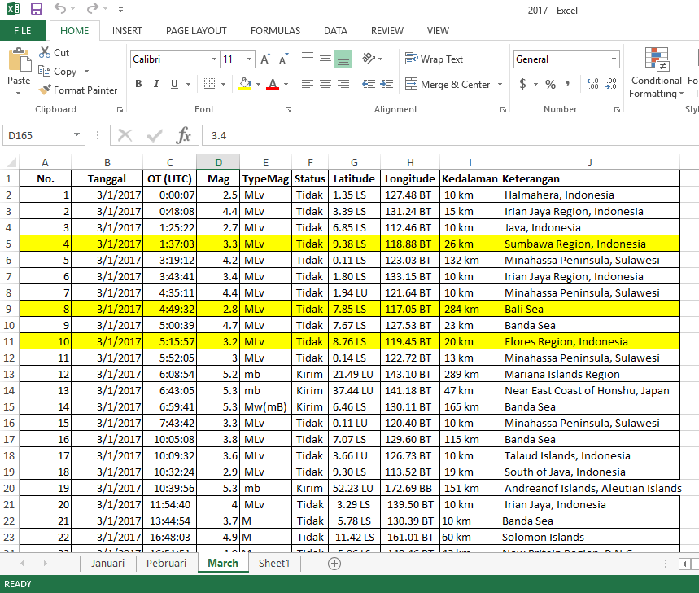

Fig. 4 (a) Microsoft Excel file from BBMKG

Fig. 4 (a) is a Microsoft Excel file from BBMKG ie data sample in March 2017., the data will be converted to the system database

Relation Database Table
Database db_sigempa, in the database there is one table that is tb_data. The database relation is designed to illustrate the relationship of each entity and attribute that realizes the entity. Here is a picture of database Relation on Design Data Conversion System of Earthquake Parameters from Microsoft Excel to Database in BBMKG Region III Denpasar.

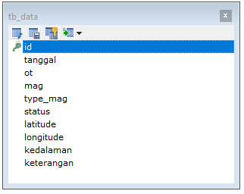

Fig. 4 (b) Relation Database Table Data Conversion System of Earthquake Parameters Data from Microsoft Excel To Database

The database built on the Earthquake Data Parameter Listing System in BBMKG Region III Denpasar does not have a table relation, this is because one of the features to input the earthquake parameter data by converting the earthquake parameter data stored in the Microsoft Excel file into the database on the Data Parameter Listing System Earthquake in BBMKG Region III Denpasar which will be made.

IV. Result and Discussion

Implementation Of Data Parameter Conversion System Of EarthQuake From Microsoft Excel To Database only has one entit ie admin. Admin here has the right to manipulate data (insert data, update data and delete data). Before entering the main page, the admin must first log into the system with the username and password that has been in the previous settings, selanjutya new admin can manipulate the data parameters earthquake.

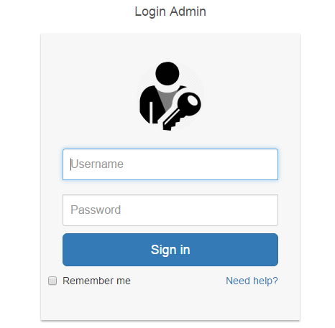
Fig. 5 Login System

Fig. 5 is the display of the Login Form on the earthquake parameter record system. The page consists of two textfields to enter a username and password. Checks are made to the input entered into the textfield on the Login page and shows the success of the login process to go to the main page of Earthquake Data Parameter Listing System application.
Date Filter is the process of searching the date of the date of the earthquake on data stored in the database. Display of date filter system can be seen in the following fig. 6.

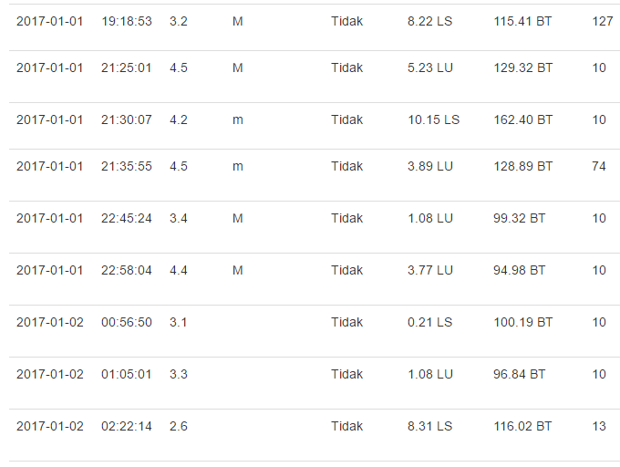

Fig. 6 Date Filter

Fig. 6 is an earthquake date filter view of data stored in the database. The image has shown filter data between 01-01-2017 and 02-02-2017 and will display data from that date.
Magnitude filter is the process of searching data from earthquake magnitude on data stored in the database. Display of earthquake magnitude filter system can be seen in the following fig. 7.

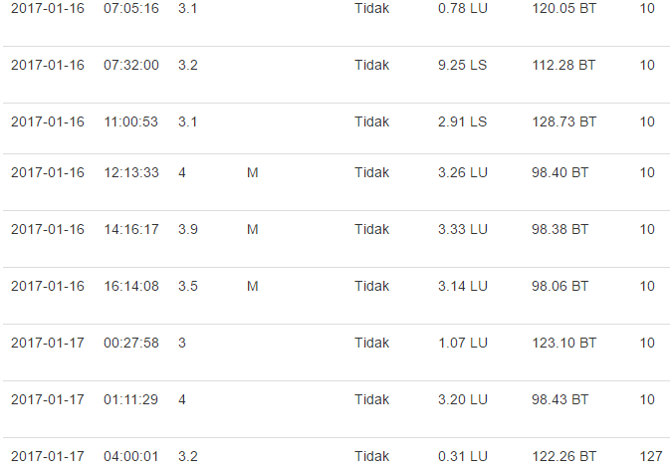

Fig. 7 Filter Magnitude
Fig. 7 is an earthquake magnitude filter view of data stored in the database. In the picture has shown the magnitude filter that occurs between 2 and 3 then the result will display the earthquake data on the magnitude filter.

How to convert Ms. data Excel to the database in earthquake parameter recording system made by students of practical work is as follows. Pertama buka halaman http://localhost/phpmyadmin then the page will appear as Fig. 8.

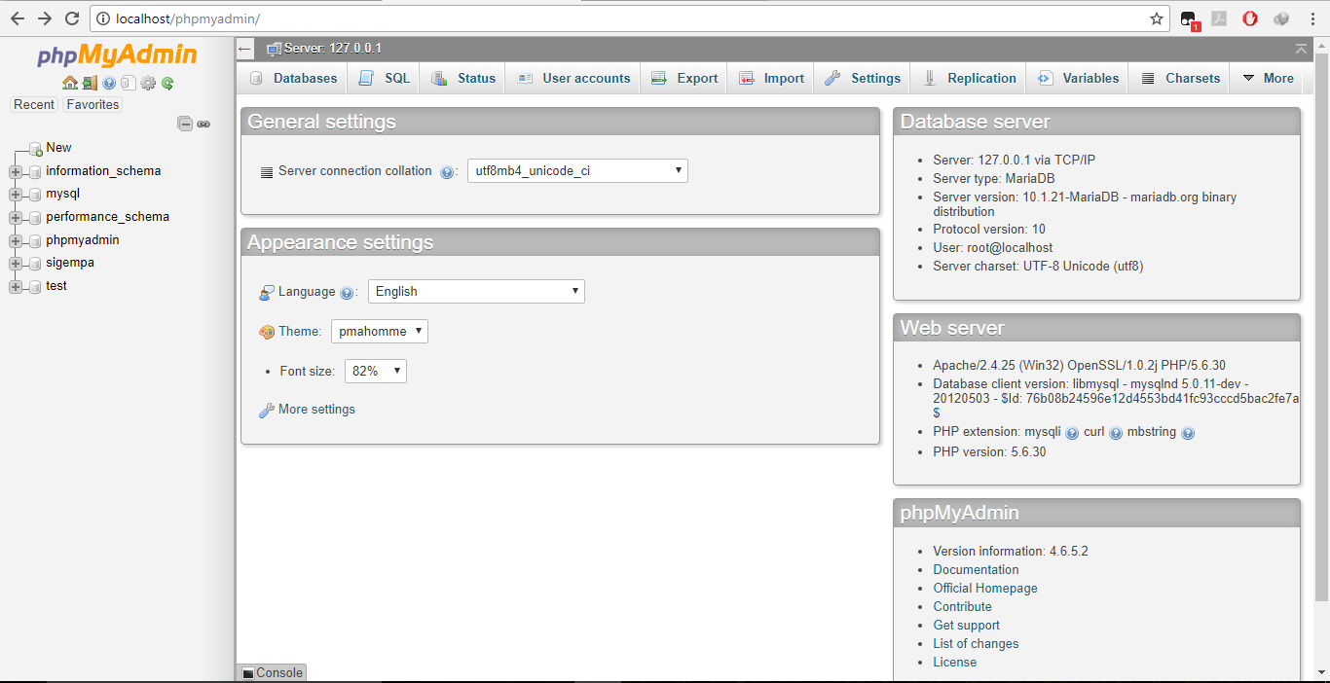

Fig. 8 Page http://localhost/phpmyadmin
Then select the database in the earthquake that is on the left. Next select the earthquake table. The next display is shown in Fig. 9.

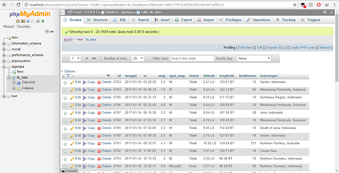

Fig. 9 View of sigempa database and tb_data
Select the Import menu, then we will be directed to select CSV file that has been made before.
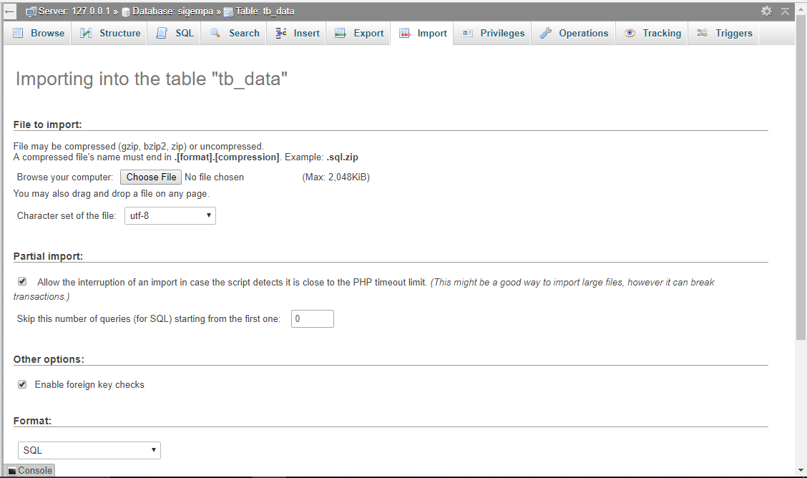

Fig. 10 Selecting the tb_data.csv file
After the next tb_data.csv file is selected press "GO" or "Go" button if using Bahasa Indonesia. Next stay wait until the process is completed da notification tone successful.
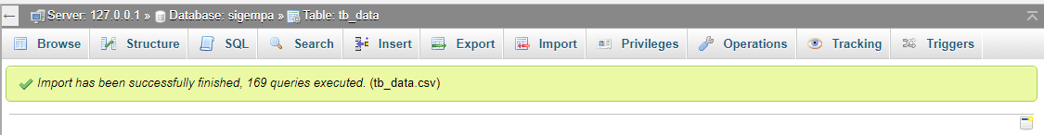
Fig. 11 Selecting the tb_data.csv file

The process of converting data from earthquake parameters of Microsoft Excel to the database has been successfully done if it has received a successful notification. To know that the data has been converted correctly we can directly view bias by selecting tb_data on the right or by opening the main page at localhost / sigempa.

Conclusion
1. Preparation of Earthquake Parameter Data Conversion System is implemented to facilitate Earthquake Parameters Data Record from Microsoft Excel to Database for BBMKG Region III Denpasar. The earthquake parameter data will be stored in the database to facilitate the processing process.
2. Features in Implementation of Earthquake Parameter Data Conversion System from Microsoft Excel to database in BBMKG Region III Denpasar is a feature of data conversion of earthquake parameters from Microsoft Excel into MySQL database. Other features are insert, update, delete earthquake parameter data.

References

[1] http://balai3.denpasar.bmkg.go.id/, “Balai Besar Meteorologi, Klimatologi dan Geofisika Wilayah III Denpasar,” 2017.
[2] http://www.bmkg.go.id, “BMKG,” 2017. .
[3] https://id.wikipedia.org/wiki/Gempa_bumi, “Gempa Bumi,” 2017. .
[4] dkk Robert G Murdick, Sistem Informasi Untuk Manajemen Modern. Jakarta: Erlangga, 1991.
[5] Gordon B. Davis, Kerangka Dasar Sistem Informasi Manajemen Bagian 1. Jakarta: PT Pustaka Binamas Pressindo, 1991.
[6] Lani Sidharta, Pengantar Sistem Informasi Bisnis. P.T. ELEX Media Komputindo, 1995.
[7] Jogianto HM, Sistem Teknologi Informasi. Yogyakarta: Yogyakarta, 2005.
[8] P. . George R. Terry, Office Management and Control, Fourth Edition. Homewood. Irwin Inc, 1962.
[9] E. Arbie, Pengantar Sistem Informasi Manajemen, Edisi Ke-7. Jakarta: Bina Alumni Indonesia, 2000.
[10] J. A. O’Brein, Pengantar Sistem Informasi. Jakarta: Salemba 4, 2005.

